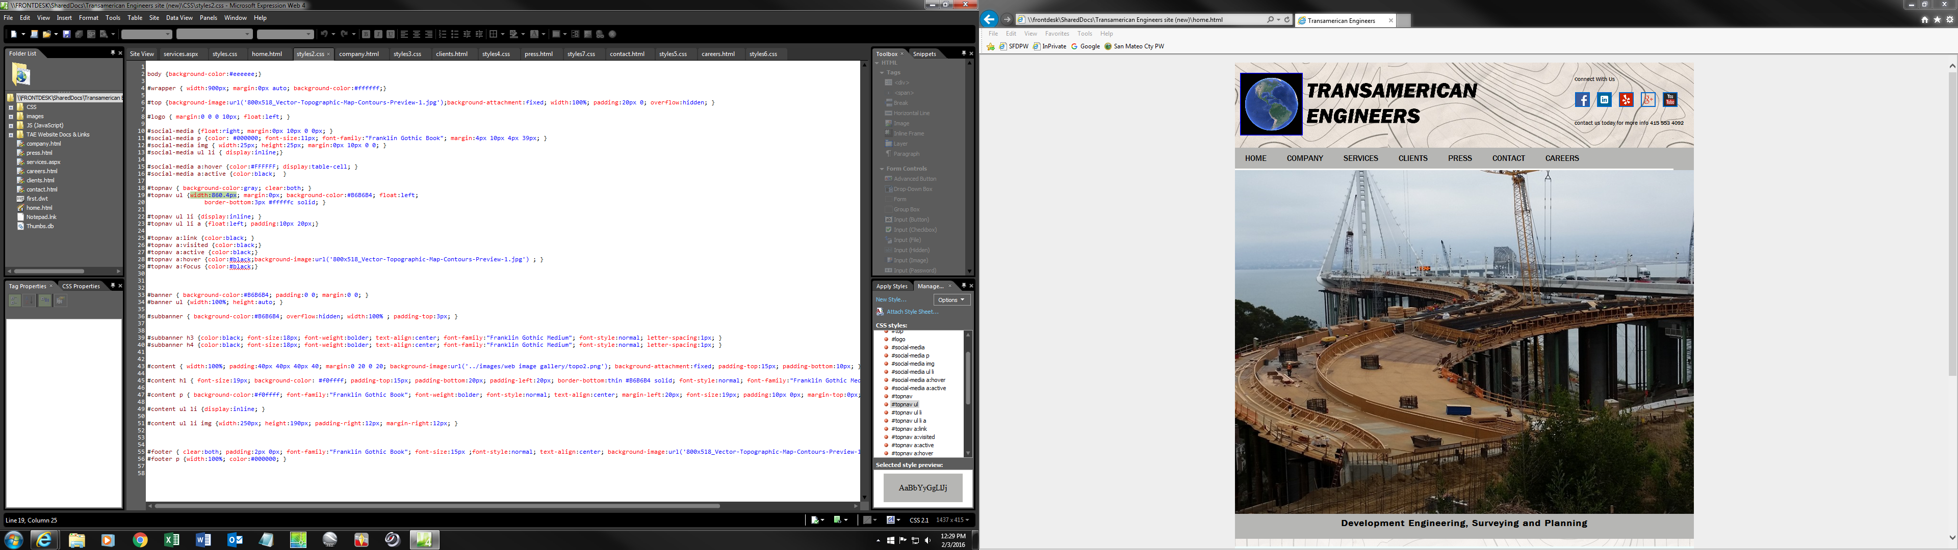

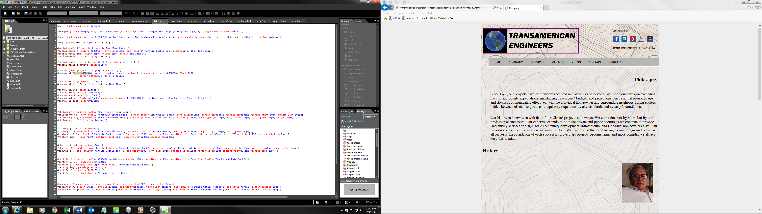

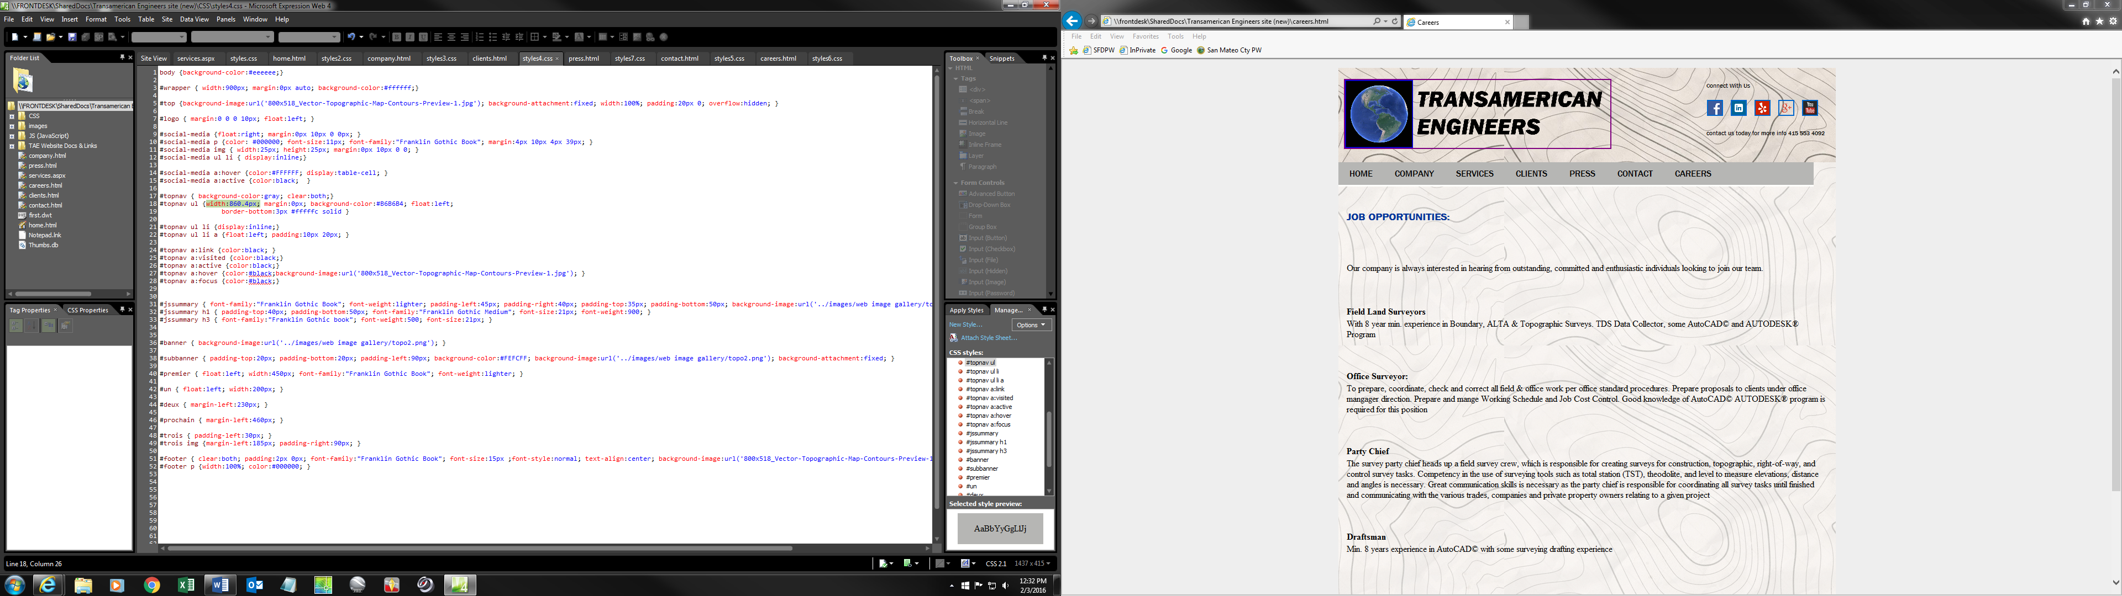

(CHANGE VALUE 860.4 pixels TO 100% for “topnav unordered list (topnav ul)” divisions is all CSS’s for old/outdated/unsupported web browser IE8 and equivalent)

